Yale Environment 360

Andes Meltdown: New Insights into Rapidly Retreating Glaciers
Using satellite data, scientists are documenting the inexorable melting of South America’s glaciers and ice fields, with Andean glaciers thinning by nearly three feet a year since 2000. The loss of ice poses a threat to water supplies and agriculture from Bolivia to Chile.

BY JONATHAN MOENS • JANUARY 30, 2020

Extracts from article

Across the Andes, glaciers have lost nearly 3 feet in thickness annually since 2000, according to Etienne Berthier, a glaciologist at the Laboratory of Geophysical Studies and Oceanography in Toulouse, France, who recently published his findings in Nature Geoscience. Warming temperatures also have caused glaciers to swiftly recede, particularly in the southern Andes, where some glaciers have retreated 5.5 miles in the past century. Ninety-eight percent of Andean glaciers have shrunk this century.
Glaciers are vital resources for communities in and around the Andes, where meltwater is used for drinking, irrigation, and hydroelectric power — especially in arid regions and during periods of drought. “The disappearance of glaciers will have an impact on the cities, but not just cities — locals, farmers, and people who do agriculture more broadly,” says Francou.

No mountain region has lost more ice, relative to its size, than the Andes.
The south Patagonian ice fields are the fastest-melting on the continent, thinning by an average of nearly 3.3 feet a year, according to Berthier’s study. Together with the northern Patagonian ice fields, these regions account for 83 percent of all ice loss in South America. The reason for this, explains Francou, is that the low-altitude glaciers of Patagonia make them particularly vulnerable to rising air temperatures.

My images from Journey to Patagonia and Chile - Feb 2019

Southern Chile glacial retreat and ice flows – 10 years ago this area in the Chilean Fjords was covered with a glacier
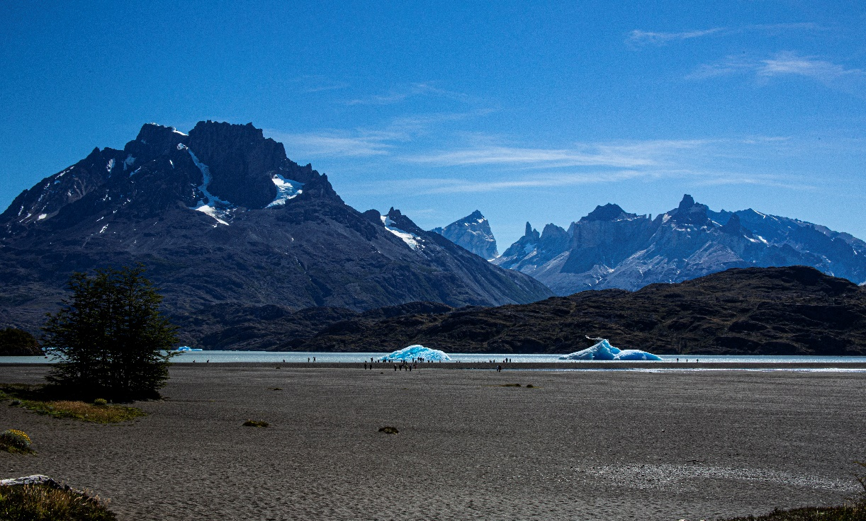
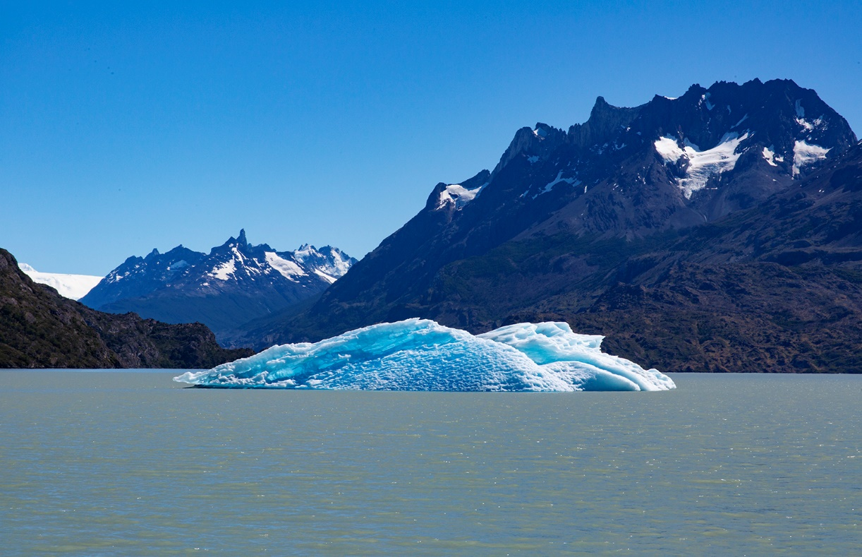

Retreating Glaciers
